NSP Registration Unit Information Form
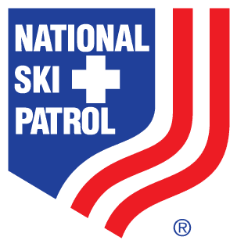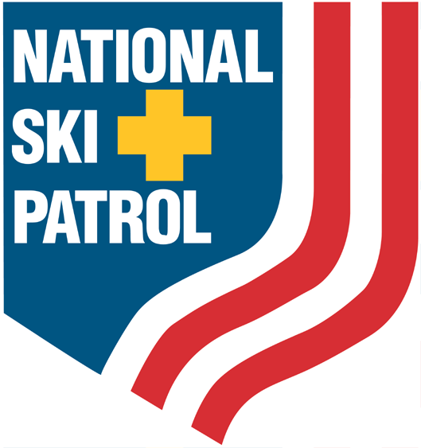
National Ski Patrol
133 South Van Gordon Street, Suite 100
Lakewood, CO 80228
Phone: 303.988.1111
Website: www.nsp.org
Email: memberrecords@nsp.org

Division Region Section

Patrol Name

Website

NSP Patrol Representative

Name __________________________________________ NSP Member ID

Address

Phone Fax Email
Patrol Type Alpine Nordic Bike (See NSP Policies and Procedures for details, section 9.4)

Please complete the following:

Ski area or land management unit served by patrol

Will the ski area be paying dues for all members? Yes No

Area manager

Name __________________________________________ NSP Member ID _______________

Title

Address

Phone _____________________ Fax ____________ Email

By signing below, the following officers have been notified of the application of this patrol to join the NSP and agree to the patrol being part of that geographic unit.

Name Signature Date
Area manager __________________ _____________________ __________
NSP Patrol Rep __________________ _____________________ __________
Section Chief __________________ _____________________ __________
Region Director __________________ _____________________ __________
Division Director __________________ _____________________ __________

